**Modelling on Mpox disease transmission model**

**Model compartment**

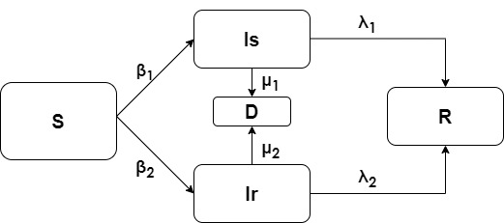

**Definition of model compartments:**

S = Susceptible population

Is = Infected population (via sexual contact)

Ir = Infected population (via direct contact)

R = Recovery

D = Death

**Definition of Parameters**

β1 = infection rate due to sexual contact

β2 = infection rate due to direct contact

λ1 = recovery rate from sexual contact infected population

λ2 = recovery rate from direct contact infected population

µ1 = death due infection from sexual contact

µ2 = death due to infection from direct contact

**Assumptions**

The following assumptions were made:

We have a closed population i.e. nil entries and exits except for deaths due to infection

There is full immunity to the disease following recovery since the immunity is obtained for a long time.

Infection through direct contact includes through contact with bodily fluids and respiratory droplets

The population is homogenous, there is no spatial heterogeneity

No exposure compartment since there is no asymptomatic transmission of the disease.

**Differential equations**

dS/dt = - (β1Is + β2Ir)S/N (1)

dIs/dt = β1IsS/N – (λ1 + µ1)Is (2)

dIr/dt = β2IrS/N – (λ2 + µ2)Ir (3)

dD/dt = µ1Is + µ2Ir (4)

dR/dt = λ1Is + λ2Ir (5)

**Initial State conditions and parameters**

|  |  |  |  |
| --- | --- | --- | --- |
| State | Definition | Value/week | Source |
| S0 | Susceptible population at time 0 | 20000 |  |
| Is0 | Infected population due to sexual contact at time 0 | 53 |  |
| Ir0 | Infected population due to direct contact at time 0 | 20 |  |
| D0 | Dead population at time 0 | 0 |  |
| R0 | Recovery population at time 0 | 0 |  |
| β1 | Infection rate from sexual contact | 1.2 | Estimated |
| Β2 | Infection rate from direct contact | 0.7 | Estimated |
| λ1 | Recovery rate from infection due to sexual contact | 0.00247 | Bhunu & Mushayabasa 2011 |
| Λ2 | Recovery rate from infection due to direct contact | 0.00247 | Bhunu & Mushayabasa 2011 |
| µ1 | Death from infection due to sexual contact | 0.00028 | Bhunu & Mushayabasa 2011 |
| µ2 | Death from infection due to direct contact | 0.00028 | Bhunu & Mushayabasa 2011 |

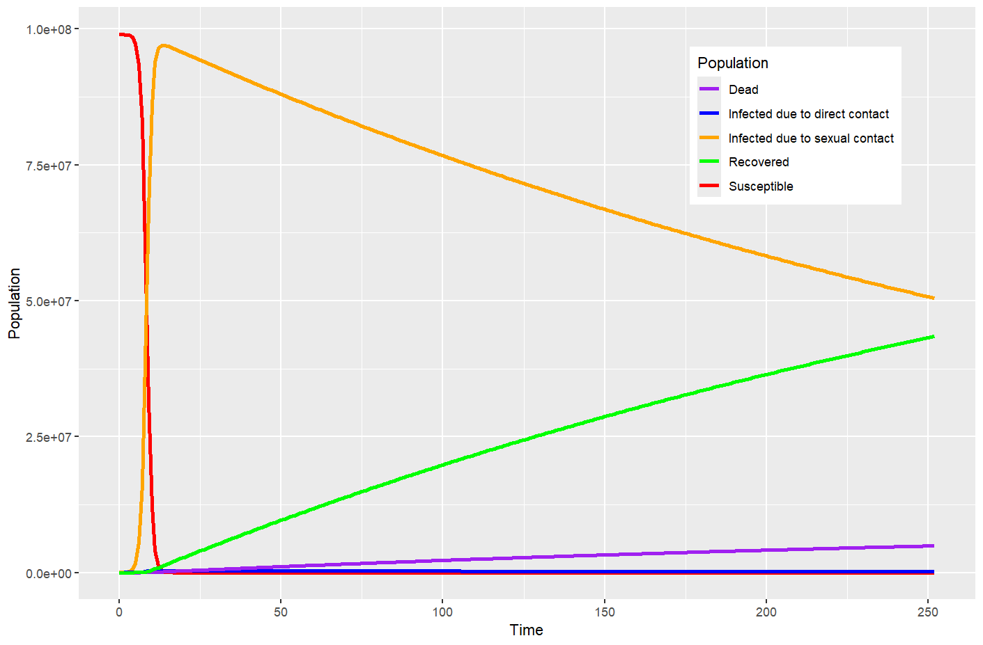**Figure 1: Model Simulation of Mpox infection dynamics**